2020
Risk Management Pla n
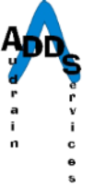
Audrain Developmental Disability Services

- PURPOSE

The purpose of the Risk Management Plan is to minimize risk to Audrain Developmental Disability Services (ADDS), individuals’ served, employees and all other stakeholders. The goals of this plan are: 1) Protection of the individuals we serve and our employees through a reduction of critical incidents, 2) Maintenance and reinforcement of ADDS’ reputation and public image and 3) Long-term sustainability of all services offered by ADDS.

- APPROACH

Audrain Developmental Disability Services is an organization funded primarily through tax authority and contracts with other government agencies. A majority of our funds are generated through the billing of services through a Medicaid Waiver system. The match for these services is generated through a county property tax. We are regulated by external organizations including our primary funders (Department of Mental Health Division of Developmental Disabilities and the Hannibal Satellite Office (RN audits, TCM audits and reviews by Provider Relations and the Business Office Staff), Case Management Monthly reviews and county audits by the State Auditor, as well as oversight and review from the Missouri Medicaid Audit Compliance (MMAC) Unit. An external audit of our financial records is completed annually by a contracted CPA, and the results of this audit are shared with the Department of Mental Health and the State Auditor’s office. In addition, we have external inspections to assess other areas of risk which include fire safety inspections annually from the City of Mexico Fire Department, consultation with information technology professionals (MOREnet) and periodic reviews from our worker’s compensation carrier. The agency follows CARF accreditation standards and undergoes a peer review from this organization at least every three years. Internally, we
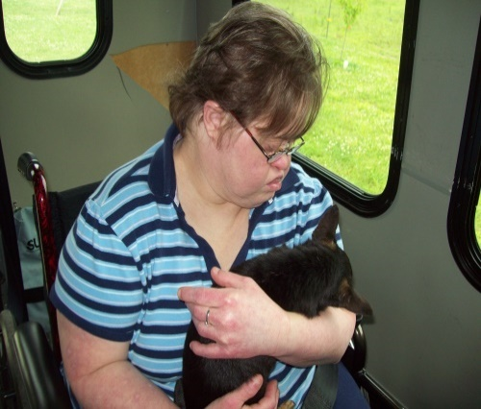
Audrain Developmental
Disability Services
222 East Jackson St.
Mexico, MO 65265

(573) 581-8210
info@audraindds.com
1
Creating a Better
Life for Audrain County Citizens

have a Safety Committee which performs reviews of our facilities and incidents, a management team headed by the Executive Director, who reports directly to our Board of Directors. Most importantly, the Executive Director and all staff are encouraged to evaluate each day for the potential risks which might be present and take the actions necessary to prevent or minimize those risks. The Risk Management Plan is approved by the Board of Directors as part of their annual review of Policies and Procedures, and the management team reviews the plan throughout the year, including the quarterly meetings of the Safety Committee.

The Board of Directors reviews the plan and its responsibilities and delegates the operational authority and responsibility to the Executive Director.

- RESPONSIBILITY

The Executive Director is delegated the responsibility to develop, manage and report on the plan. The Executive Director may involve additional individuals such as the Management Team and Safety Committee, as well as any other resources used to access and manage the organization’s risk. The Executive Director shall report at least annually to the Board on the Risk Management Plan.

- OVERVIEW OF METHODS AND STRATEGIES TO ADDRESS RISK

The first step in the development of risk management is recognition of what are potential threats to the organization. Once the risks have been identified the plan then must be developed such that the risks are either avoided or minimized by the plan. In addition, the plan should include any critical modifications which are necessary to reduce the level of risk. Other strategies include an acceptance of risk which results in some cost to the agency. The costs should then be identified and a decision be made to reduce exposure if those costs outweigh the benefit of assuming the risk.

Creating a Better
Life for Audrain County Citizens
Audrain Developmental
Disability Services
222 East Jackson St.
Mexico, MO 65265

(573) 581-8210
info@audraindds.com
2

- COMMUNICATION AND REPORTS

The Risk Management Plan is communicated to all ADDS employees, individuals served and other stakeholders of ADDS so that they can participate in the identification, removal and modification of risks. The results of the Risk Management Plan shall be reported to the Board of Directors at least annually. It is expected that any identified emerging or immediate risk be shared with management and the Board of Directors at the first available opportunity.
Creating a Better
Life for Audrain County Citizens
3
Audrain Developmental
Disability Services
222 East Jackson St.
Mexico, MO 65265

(573) 581-8210
info@audraindds.com

- OUTCOME PROCESS

The Board of Directors, in consultation with the Executive Director, Safety Committee and Management Team, shall make adjustments to the Risk Management Plan as necessary. These changes may involve policy changes, as well as changes to the short- and long-term goals of the organization.

