January 2020
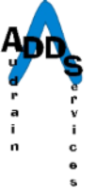
Cultural
Competency Plan
Audrain Developmental Disability Services

Audrain Developmental Disability Services (ADDS) is an agency formed by the people of Audrain County for the support of county residents with developmental disabilities and their families. We provide an array of services to fulfill this function. Services offered, include residential services (group homes, apartment living programs, and independent supported living arrangements), independent living services, natural home supports, developmental training, supported employment, transportation, family support, case-management, advocacy and referral. Our goal is to expand the opportunities for independence in the lives of people with disabilities and to support them in their achievement of their highest potential in community life. As part of the opportunities supported we recognize the importance of cultural influences in everyone’s lives, whether the cultural influences are the membership in a particular ethnic/religious group or membership or identity in some other cultural group, such as the deaf community. Cultural difference may also be associated with being raised in an urban versus rural community. Most importantly we recognize every individual we serve and all of our employees have different backgrounds and life experiences which have shaped who they are and effects the choices they make in life. We need to be ever aware, accepting and supporting of individual differences and desires.

- TRAINING

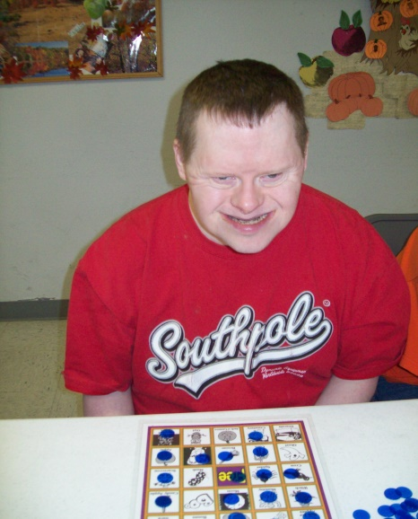
ADDS provides a training regarding cultural diversity upon hire to each new ADDS employee and ADDS requires an annual review and discussion of cultural diversity by each employee. These annual trainings take place with a small group of employees in order to encourage discussion and questions. ADDS can also assist staff in locating and attending conferences and offering in-house training when
Audrain Developmental
Disability Services
222 East Jackson St.
Mexico, MO 65265

(573) 581-8210
ahs@ktis.net
3
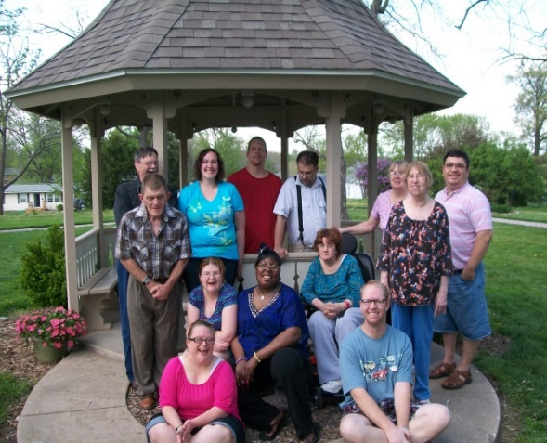
Audrain Developmental
Disability Services
222 East Jackson St.
Mexico, MO 65265

(573) 581-8210
info@audraindds.com
1
Creating a Better
Life for Audrain County Citizens

it needs to be focused toward a specific individual, family or staff member. We support linguistic accomodations and contract with individuals/agencies to provide interpretation.

- RESOURCES

ADDS provides information summarized from CARF as well as Department of Mental Health as a springboard for discussion with staff annually. A resource developed by the Missouri Department of Mental Health, Philosophy & Values: Cultural Diversity, is available in all program locations where services are provided. Other references may be purchased and provided as the need arises.

ADDS has a contract with an interpretive services agency and also has knowledge of Spanish interpretation services available in our area and we can use a telephone interpreting service such as Language Line as well.

- CULTURAL DEMOGRAPHICS

ADDS Management Team reviews at least annually the demographics of the service area and works to respond to the needs of the community. It is very important that our Agency remain aware of the local demographics as we seek employees to offer support to the individuals we serve.

The service area of ADDS – Audrain County, Missouri – is very similar to the general population of Missouri. The population in our local community and county is approximately 87% white, non-hispanic with just a bit less than 10% black and/or 2 or more races. Our community does have a population of approximately 2% Spanish speakers. The workforce of ADDS is somewhat similar with just over 15% of employees of black and/or 2 or more races and just under 85% white and no one who is non English speaking. The individuals served represent very similar demographics. As an Agency, efforts are made to ensure that individuals served are comfortable with direct support professionals whether that be race, gender, age, etc.

Audrain Developmental
Disability Services
222 East Jackson St.
Mexico, MO 65265

(573) 581-8210
info@audraindds.com
2
Creating a Better
Life for Audrain County Citizens

Audrain Developmental
Disability Services
222 East Jackson St.
Mexico, MO 65265

(573) 581-8210
info@audraindds.com
2
Creating a Better
Life for Audrain County Citizens
- GENDER

The workforce at ADDS is not similar to the population of the community within which ADDS is located. Audrain County, Missouri is 54% female while females represent approximately 85% of the ADDS staff currently. This is similar as females continue to be over-represented in many human service professions and especially in areas of support staff. Our agency does make efforts to ensure male staff are available as much as possible in areas where this seems valued and important. It should be noted that the Management team at ADDS includes 2 male and 6 females.

- AGE

The population served by ADDS in group and residential facilities is an aging population while many of those served only by support coordination services represent an age group under 18. ADDS is attempting to reach out appropriately to this younger population with the recent expansion of support coordination services to include a resource specialist who will be working together with schools and the education system to provide appropriate services to this age-group. The Director of Health Services provides insights into some of the needs of the aging population such as dementia, increased physical needs, etc.
Although many of the Direct Support Professionals are young, there is also a representative group of staff in their 40’s and above.

- SEXUAL ORIENTATION

It is noted that the sexual and gender orientation of employees and individuals served is not identified, ADDS does employ staff members who will provide support and care to individuals we serve, as well as work together with others who may have differing sexual orientations.

- SPIRITUAL BELIEFS

The area served by ADDS is predominantly Christian with only a few individuals/families in Audrain County who share other basic beliefs. There are small Amish and Mennonite

Audrain Developmental
Disability Services
222 East Jackson St.
Mexico, MO 65265

(573) 581-8210
info@audraindds.com

Audrain Developmental
Disability Services
222 East Jackson St.
Mexico, MO 65265

(573) 581-8210
info@audraindds.com
3
Creating a Better
Life for Audrain County Citizens

Audrain Developmental
Disability Services
222 East Jackson St.
Mexico, MO 65265

(573) 581-8210
info@audraindds.com
Audrain Developmental
Disability Services
222 East Jackson St.
Mexico, MO 65265

(573) 581-8210
info@audraindds.com

3

populations. There are some variations in some holidays
and the needs of those individuals (whether employees or
individuals served) are respected. Accurate demographic data is difficult to assess in this area.

- SOCIOECONOMIC STATUS

ADDS serves individuals qualifying for service due to
having a qualifying developmental disability. Developmental disabilities impact on individuals regardless of socioeconomic status although it seems that many of the
individuals served do have income and resources associated
with poverty. This may be due to difficult employment issues and interpersonal difficulties secondary to the developmental disability. ADDS also finds that many of the direct support professionals seeking jobs in the area of 24/7 care often have socioeconomic difficulties that result in the need for evening, night or weekend positions. In the past year ADDS has participated in some workshops and planning activities that are investigating the role that lower socioeconomic status plays in the area workforce and ADDS, along with other local employers are making efforts to improve the level of support and training for individuals in poverty situations.

- LANGUAGE

As mentioned previously, ADDS works toward providing services in a language or communication modality that will be most appropriate for the individuals served. Interpreting services are available and in some of the residential facilities a number of staff know some sign language. At this time there are no non-English speaking individuals receiving services but ADDS has access to individual interpreters who can offer assistance. At this time ADDS does not have any current non-English speaking employees not has ADDS received any employment inquiries from non-English speaking individuals – this is likely due to the small, if any, non-English speaking individuals in the local community.

Audrain Developmental
Disability Services
222 East Jackson St.
Mexico, MO 65265

(573) 581-8210
info@audraindds.com
4
Creating a Better
Life for Audrain County Citizens

- GOALS FOR 2020

- Training in cultural diversity upon orientation of new ADDS staff will continue as this offers an opportunity to increase awareness of employee’s own needs and concerns as well as an educational opportunity.
Audrain Developmental
Disability Services
222 East Jackson St.
Mexico, MO 65265

(573) 581-8210
info@audraindds.com
5
Creating a Better
Life for Audrain County Citizens
- Annual reviews and discussion of cultural diversity concerns will continue.
- Review by management staff as needed regarding special arrangements for staff, individuals served will continue – especially as it related to hiring appropriate staff for special circumstances related to individuals served.
- Attempt to hire staff members with knowledge of the deaf community to serve in the residential homes of individuals served where appropriate.
- Continue to encourage management staff to discuss cultural diversity issues regularly at staff meetings as the need arises or in efforts to increase knowledge of employees.
- Continue to assess and offer appropriate cultural diversified activities to individuals served.
- Utilize resources from Missouri Department of Mental Health’s curriculum.

